Step1:Install git in your machine.

Step 2:Create User accounts in git hub and gitlab.

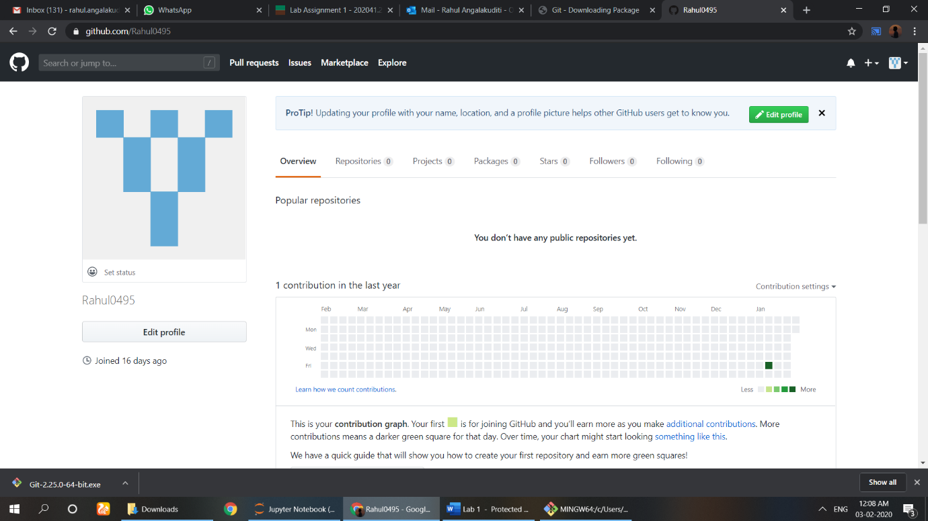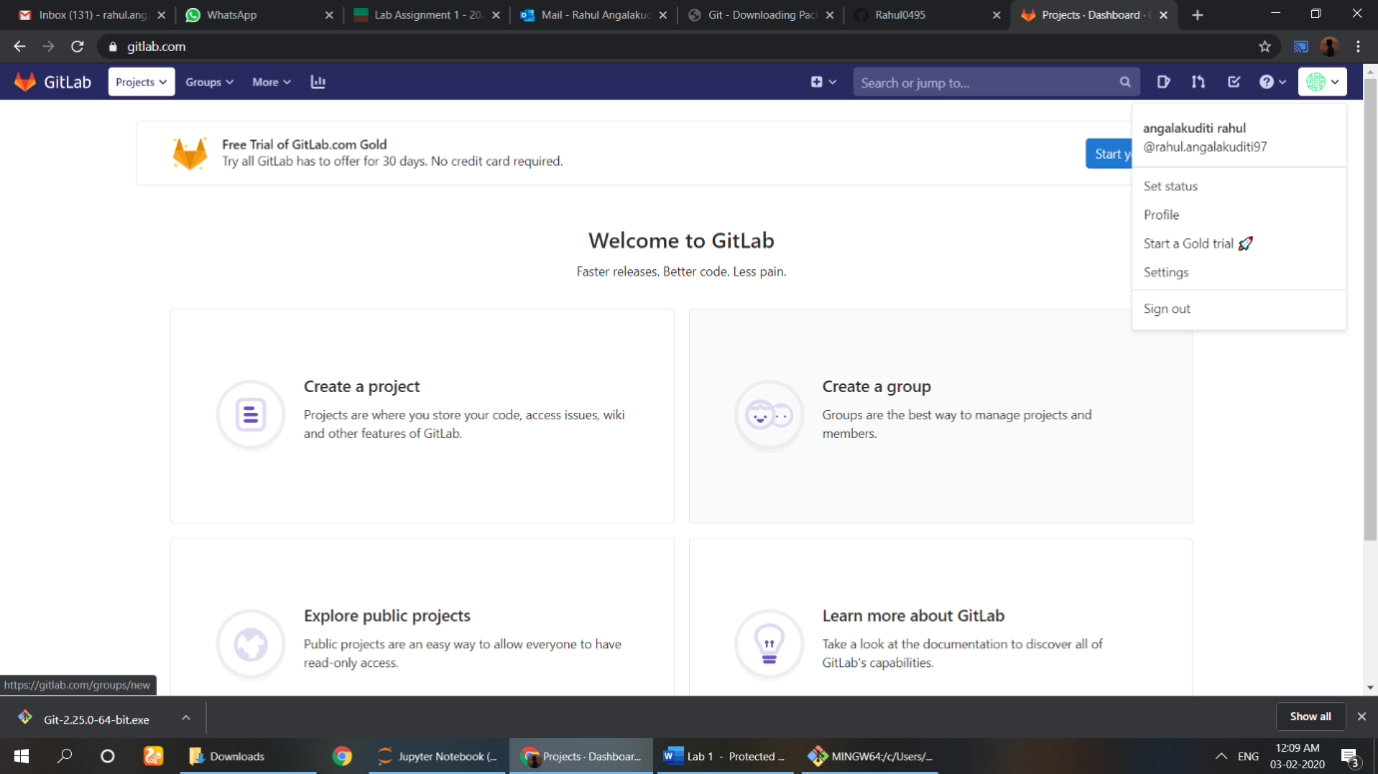

Step3: Review github and gitlab. Select your remote host

Step4:

Basic Programming

Step5:Screenshot of your cmd showing success of commit

Step7:

Step 8: Navigate to your newly created branch and provide screenshot showing status of your repo

Step9:

Step 10:

Make your repo public and share the link of your repo for check.

Link: https://github.com/Rahul0495/1st_lab.git